Project Performance Testing

Date | 8 July 2026
Team ID
Project Name | Food Ordering &Customer Trends
Maximum Marks

Model Performance Testing:
S.No. | Parameter | Screenshot / Values
1. | Data Rendered | The housing dataset was successfully uploaded and rendered in Tableau Public. All dataset fields, including Sale Price, Bedrooms, Bathrooms, Flat Area, Floors,  Basement Area, House Age, Renovation Status, Overall Grade, were loaded correctly and made available for further analysis.  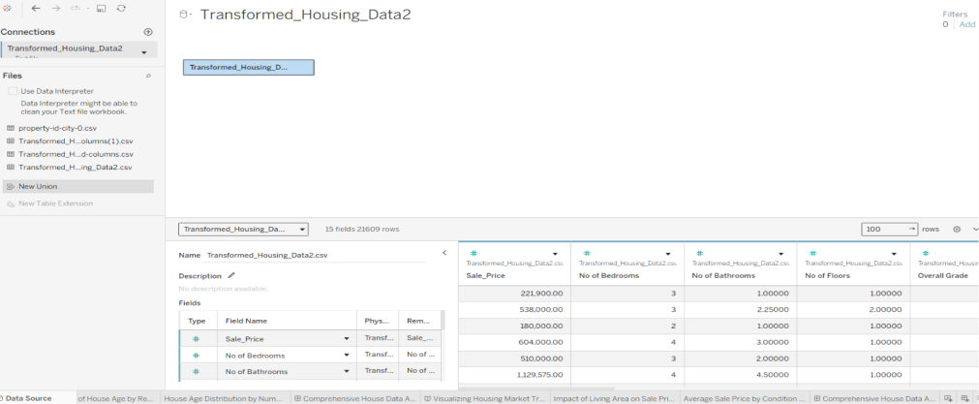
2. | Data Preprocessing | Removed null values, verified data types, created calculated fields, grouped Zipcode (1–9), validated renovation and condition fields before visualization.  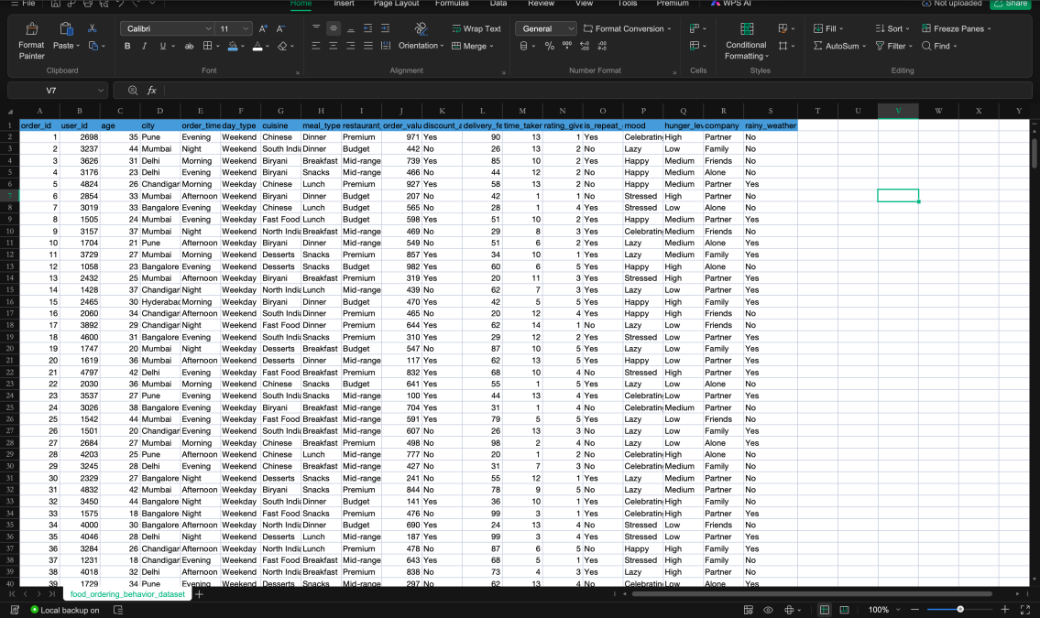

3. | Utilization of Filters | Filters used:  Aggregation functions: SUM(Usage) was primarily used for total load mappings, and AVG(Usage) was applied to monitor ongoing baseline shifts. Worksheets  utilize coordinated dynamic action filters to allow synchronized dashboard cross-  filtering.
4. | Calculation fields Used | IN this Visualization (Total Orders ) Use Create Calculation field and other visualization normal calculation fields Use.  Logic / Syntax: Mapped via custom integer parameters linked with rank/index functions (INDEX()) to dynamically filter states based on the selection.  Purpose: Solves Tableau's order of operations conflict, allowing the dashboard to dynamically rank the top or bottom states within specific geographical region  filters without breaking.
5. | Dashboard design

All Visualization in use Dashboard Design (Food Ordering & Customer Trends)

f.g.->Deshbord 1

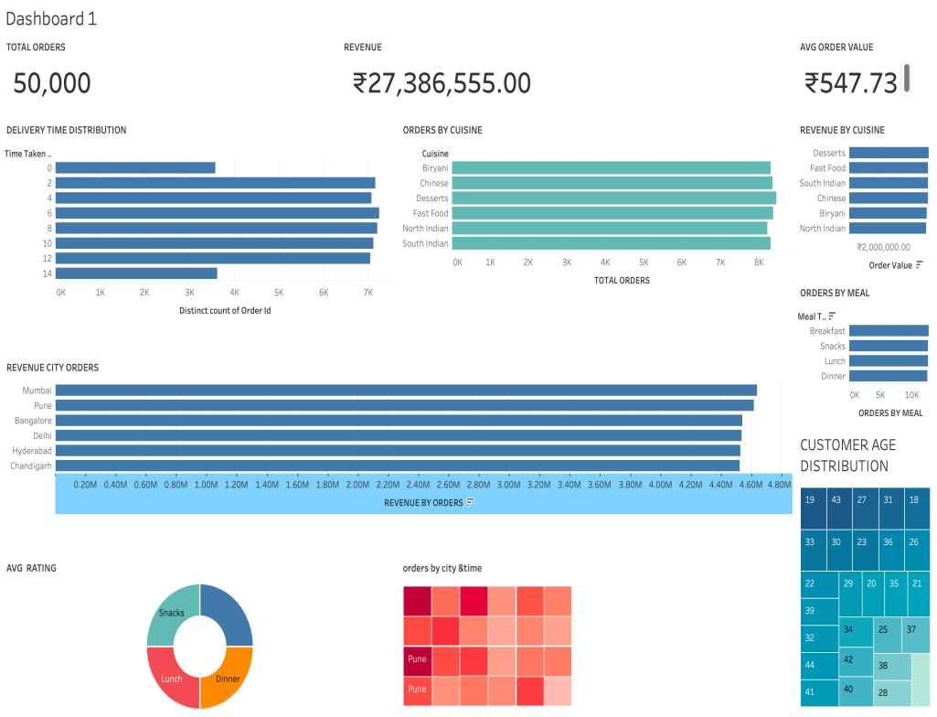
6. | Story Design | Food Ordering and Customer Trends using Tableau Story .Multipal stories are created into the Tabula story .  